MLOps Term Project: Data Engineering Pipeline Report
1. Introduction and Objective
This project aims to establish an end-to-end Machine Learning Pipeline to predict student course completion status. This part of report covers the Data Engineering phase of the project, encompassing the process from data ingestion to cleaning, feature engineering, and preparation for modeling.
The primary objective is to transform raw data into optimized, high-quality training and testing sets (processed data) suitable for a high-performance classification model.

2. Pipeline Architecture and Workflow (DAG)
The project utilizes a modular ETL (Extract, Transform, Load) structure orchestrated by Apache Airflow within a Dockerized environment. This design ensures data reliability and reproducibility.
Workflow Steps:
- Ingest: Loading the raw CSV data into the system.
- Validate: Verifying data types and schema integrity.
- Preprocess: Formatting dates and encoding the target variable (Completed: 0/1).
- Feature Engineering: Applying advanced transformations to enhance model performance.
- Split & Balance: Splitting data into sets and addressing class imbalance.
- Save: Versioning and saving the processed datasets.
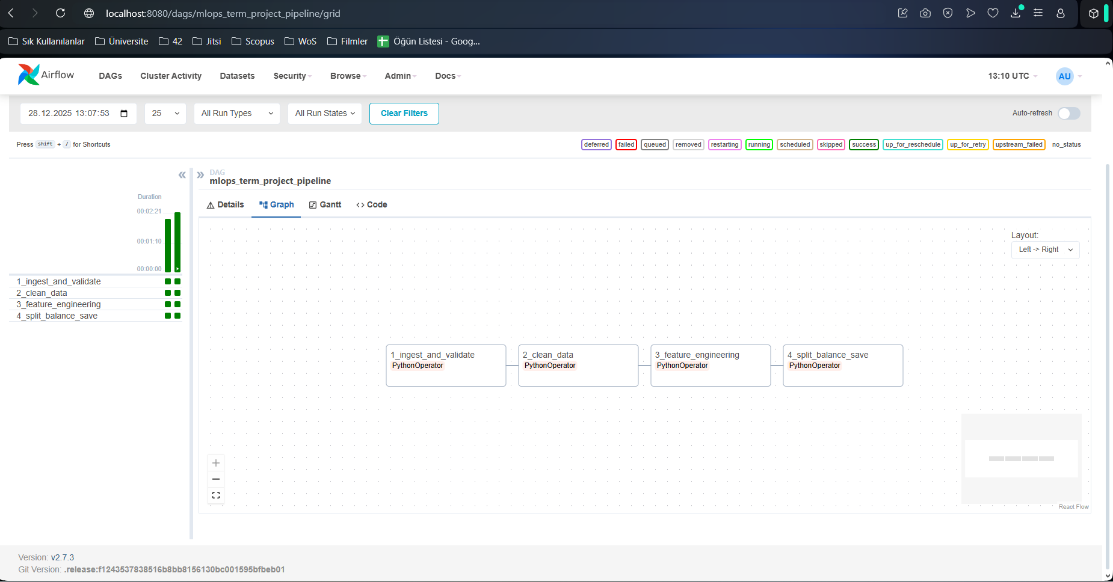

3. Applied Design Patterns
To meet the requirements outlined in the Project Proposal, the following advanced data processing techniques have been implemented:
A. Feature Interactions (Feature Cross)
To enable the model to learn relationships between categorical variables more quickly, the Feature Cross technique was applied.
- Method: The Category and Course_Level columns were concatenated to derive a new feature named Category_Level_Cross.
- Code Reference: src/features.py -> apply_feature_cross
B. High Cardinality Handling
The Student_ID column, which contains a high number of unique values, was processed using the Hashing Trick pattern to maintain memory efficiency and prevent dimensionality explosion.
- Method: Using FeatureHasher, thousands of student IDs were compressed into a fixed number (100) of "buckets." This method is significantly more efficient than One-Hot Encoding for high-cardinality data.
- Code Reference: src/features.py -> apply_hashing
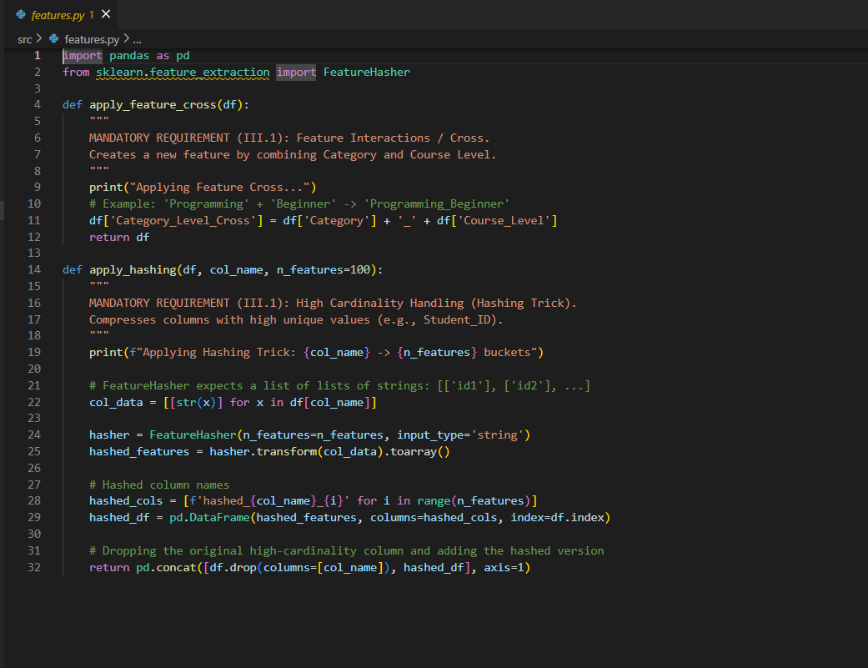

C. Handling Imbalance
To address the imbalance between "Completed" and "Not Completed" classes, a Rebalancing strategy was applied to the Training set.
- Method: The minority class was increased using Upsampling (Resampling) until it matched the majority class count. Crucially, this was applied only to the train data after splitting to prevent Data Leakage.

4. Data Validation and Testing (Quality Assurance)
Both data validation and code testing mechanisms are integrated to ensure pipeline stability.
- Validation: Input data undergoes schema checks before entering the pipeline logic.
- Unit Tests: The logical correctness of feature engineering functions (apply_feature_cross, apply_hashing) is verified using the unittest library, independent of the actual dataset.
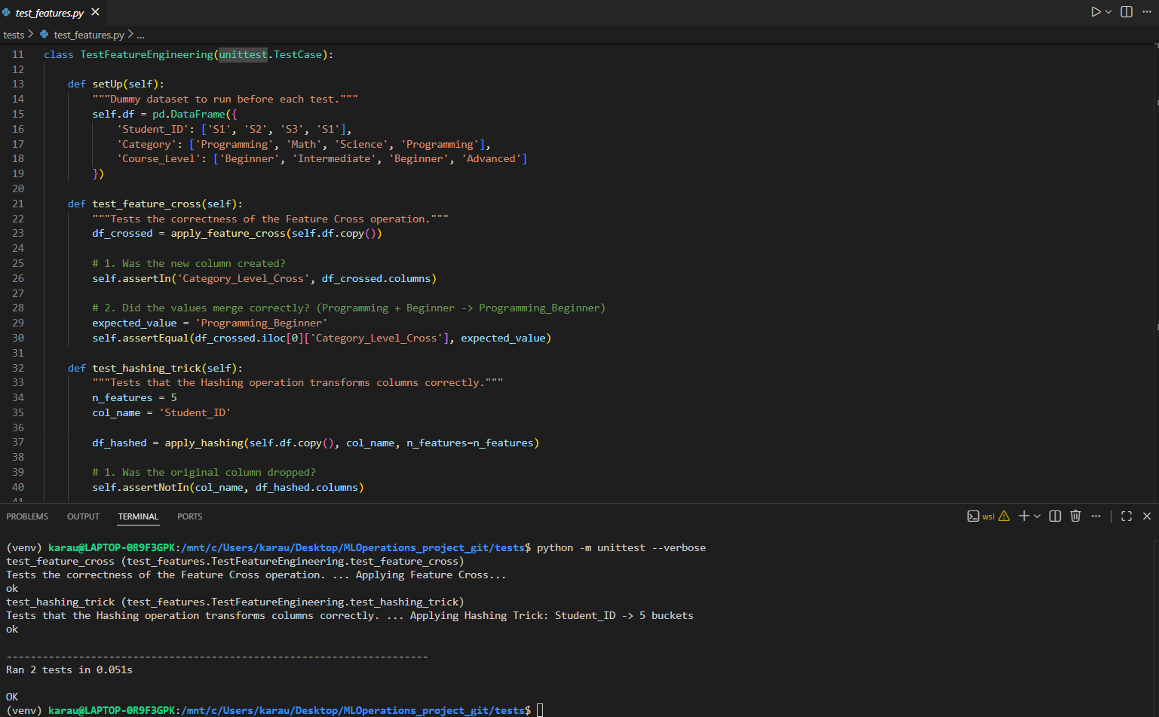

5. Conclusion and Outputs
Upon execution of the pipeline, the raw data is successfully processed and made ready for model training.
- Input: data/raw/Course_Completion_Prediction.csv
- Outputs:
    - data/processed/train_processed.csv (Balanced, Hashed, Feature Crossed)
    - data/processed/test_processed.csv (Hashed, Feature Crossed)
The system saves these optimized datasets to the designated directory, ready to be consumed by the model training module (train.py).
